Paper Helicopter
Subject:  Related Subjects: | Grade Level(s): 8  Length of Lesson: | Type: Inquiry / Design / Project  Keywords: gravity

Lesson Overview
The paper helicopter is a demonstration of the principles of gravity and drag. In this experiment, gravity and drag act in opposite directions. The rotation of the paper helicopter ensures that drag is maximized, increasing the time needed to reach the ground. It is a simple experiment, and requires little preparation, but can be modified by having the students alter their prototype after an initial field test.

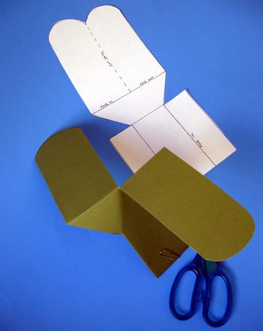

Lesson Focus
What is the central question or phenomenon being investigated? What problem are they trying to solve?

Lesson Objective(s) | By the end of this lesson, students will…  - Learn the concepts of attraction, repulsion, friction, polarity, and charge.

Lesson Timing

5 minutes | Introduce the Lesson
30 minutes | ...

Materials | - Paper with Paper Helicopter template printed  - Paper Clips  - Scissors
Instructor Prep | - Step 1
Related Resources | - List related lessons/ppts etc available from USC or outside, trusted orgs

Lesson Plan

Introduction
Introduce students to the learning goals and make connections to past and present learning experiences. Stimulate interest and prompt students to identify their own questions about the topic. This can link the lesson to real world examples, introduce associated STEM careers, and assess their prior knowledge on the topic.

- Step 1

Procedure
- Each student takes 1 sheet of paper, 1 paper clip, and 1 pair of scissors.
- Cut and fold according to the directions on the template.
- Attach a paper clip to the bottom of the paper helicopters.
- Have students compete to see whose paper helicopter glides for the longest.
- Allow students to modify their designs and have a second competition.

Wrap-up
End the lesson with some final discussions about what students designed/discovered. Connect their activity back to the focus question/problem, real world examples, and STEM careers.

Also include notes about any special cleanup considerations

Lesson Background for Teachers

Suggested Real-World STEM Connections
- List possible related Role Models in STEM (with details and links to more reading). Give suggestions for examples of scientists/engineers who are from underrepresented groups in STEM in related careers.
- List related real-world engineering problems and examples

Lesson Variations and Options
Include descriptions of alternative methods or ways to present things.

Explanation
Describe the background concepts and explanations behind the lesson. This can be more in depth than a teacher/instructor would actually share with students.

Key Concepts and Vocabulary
- Word 1: Grade Appropriate Definition
- Word 2: Grade Appropriate Definition

Safety Notes
- Safety instruction

